Caribbean Maritime Institute

The Jamaican Legal System
• Main sources of Law
• The Courts
• Tribunals and Arbitrations

The Jamaican Legal System is known as a “Common Law” system. The Common Law
system is one of the three major types of legal systems in the world. The other two are
Civil Law (based on Codes) and Religious Law (based on Religious Texts). Some legal
systems involve a combination of two or in a few instances all three of these types.

The Common Law System originated in England and in its earliest form was based on
societal customs and norms recognised and enforced by the judgments and decrees of
the courts. Over time, used in a broad sense, the term “Common Law” came to include
these early customs as well as legislative enactments and the judicial decisions
interpreting their application. The Common Law system became therefore the law
(custom, statutes and judicial decisions) common to all of England. Jamaica, as does the
rest of the Commonwealth Caribbean, has a Common Law legal system inherited from
England.

In the Common Law system court decisions are heavily reliant on prior judicial
pronouncements. Where a statute governs the dispute, judicial interpretation of that
statute determines how the law applies. Under the doctrine of Stare Decisis (latin for
“let the decision stand”) courts in our Common Law system are obliged to follow the
decisions and rulings in previously decided cases, or precedents, where the facts and

issues are substantially the same. In Jamaica therefore, a court's decision is binding
authority for similar cases decided by the same court or by lower courts within the
Court Structure. The decision is not binding on courts of higher rank but it may be
considered as persuasive authority. Decisions from courts outside of Jamaica are not
binding, but may also be referred to as persuasive authority if there is no local case
which has settled the point in issue

Cases that come before the courts deal with myriad everyday situations. Additionally,
disputes involving new discoveries, technologies, social changes or global developments,
often raise novel legal issues which are previously undetermined in Jamaica, and for
which no binding precedent exists. Our Common Law system allows our judges to look
to other jurisdictions or to draw upon past or present judicial experience for analogies,
to help in making decisions in those situations. This flexibility enables the courts to
address new situations so that no worthy litigant is left without a remedy. At the same
time the doctrine of stare decisis provides certainty, uniformity, and predictability
which promotes a stable legal environment.

In the Common Law system, disputes are settled through an adversarial exchange of
evidence and argument. Opposing parties present their cases before a neutral fact
finder. Depending on the type of case, the fact finder may be either a jury or a judge.
Where a Judge sits with a jury, the jury are the fact finders. Where the Judge sits alone,
the judge has the dual responsibility of determining the appropriate law to apply, as well
as the facts proved. Where the Judge sits with a jury, the Judge directs the jury on the
relevant law to be applied to the facts the jury finds proved. The jury or the judge, as the
case may be, evaluates the evidence, applies the appropriate law to the facts, and
thereby arrives at a decision. Following the decision, the party against whom the
decision is made, (with the exception of the prosecution in a criminal case on a verdict
of acquittal), may appeal the decision to a higher court.

Under our Common Law system, all citizens of whatever rank or status are subject to the
same set of laws, and the exercise of governmental power is limited by those laws. The
Supreme Court is empowered to review legislation, but only to determine whether it
conforms to constitutional requirements.i

The Court Structure and Hierarchy

The structure of the Jamaican Judicial System is based on five basic tiers. The lowest
tier is the Petty Sessions Court. This court is presided over by Justices of the Peace. The
Petty Sessions Court requires a minimum of two justices to be properly constituted.
Sometimes Magistrates exercise jurisdiction in these courts and the presiding
magistrate exercises the jurisdiction of two Justices of the Peace.

Appeals from this court are to the Circuit Court of the parish in which the Petty Sessions
Court sits or by way of case stated to the Court of Appeal

The next tier of court is the Resident Magistrates’ Court. This court is an inferior court
of record and, as is the case with the Justices of the Peace jurisdiction, is governed
entirely by statute. Resident Magistrates have the jurisdiction to try cases summarily as
well as on indictment. The level of sanction, in terms of fines and imprisonment, are
lower than that which may be imposed in the Supreme Court.

Resident Magistrates preside over a range of courts at this level. Apart from exercising
jurisdiction in criminal cases, Resident Magistrates preside over the Coroner’s Court,
Traffic Court, Drug Court, Tax Court, Family Court, Juvenile Court and Civil Court. The
jurisdiction of the Civil Court is limited to claims not exceeding $250,000.00.

Appeals from the Resident Magistrates’ Court are also to the Court of Appeal.

At the third tier, the Supreme Court is the highest first instance court. It is a superior
court of record and has unlimited jurisdiction. It has both inherent and statutory
jurisdiction. Courts of equivalent jurisdiction in other countries are sometimes called
“High Courts”.

The Supreme Court has jurisdiction in Civil, Criminal, Family, Commercial, Succession
and Admiralty cases. There are also specialised courts which also exercise superior
jurisdiction which are presided over by Supreme Court Judges. These are the High and
Circuit Court Divisions of the Gun Court and the Revenue Court

Appeals from the Supreme Court are also made to the Court of Appeal.

The Court of Appeal is the court to which all appeals are first referred. The Court of
Appeal is the fourth tier of the court structure. Its procedure is governed by statute. It
may confirm, overturn or vary judgments in any cases in which there are appeals from
any of the first-instance courts.

In the majority of cases the decisions of the Court of Appeal may be subject to appeal to
the Judicial Committee of the Privy Council (The Privy Council). Technically, the appeal
is to the Head of State which is the Sovereign. The Privy Council hears the appeal and
makes a recommendation to the Sovereign as to the manner in which the appeal is to be
resolved. It may recommend confirmation, overturn or variation of the judgment of the
Court of Appeal. The Privy Council is the fifth and highest tier of the Jamaican Court
System. Appeals to the Privy Council are restricted to cases of a certain monetary value
or where they are of exceptional public importance.

Arbitration and Tribunals
In recent times, methods of alternate dispute resolution have become a popular
alternative to court. These methods are less costly, more confidential and tend to cater
to the interest of all the parties of the dispute a bit more than the court system.
In Jamaica, the main body that deals with arbitration and mediation of disputes is the
Dispute Resolution Foundation and one of the most active tribunals is the Industrial
Disputes Tribunal, which deals specifically with labour matters.

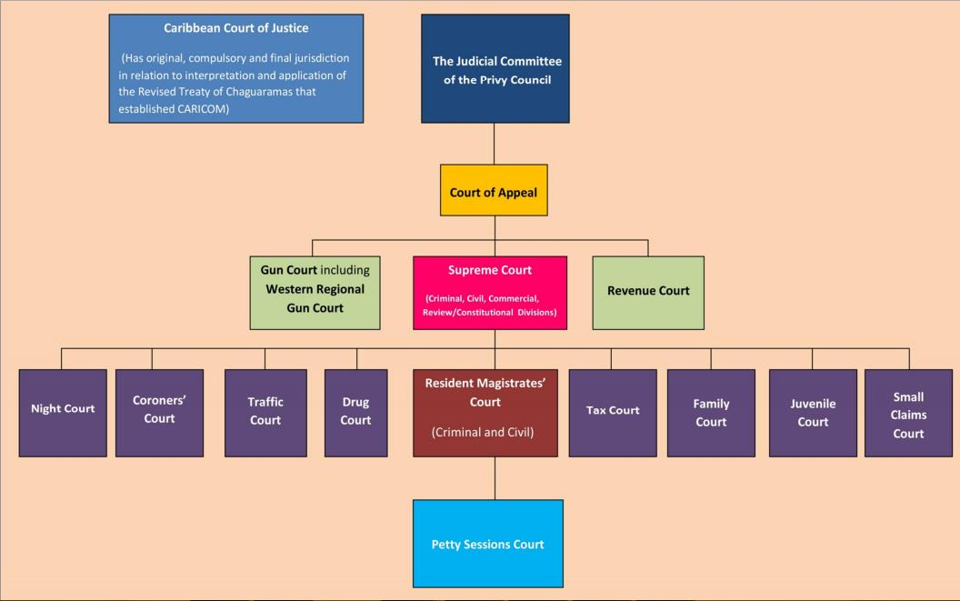

i http://supremecourt.gov.jm/content/legal-system
ii http://supremecourt.gov.jm/content/court-structure-and-hierarchy

