

Distance Education Course ML–301.1
General Ship Knowledge
Lessons 2 and 3 cover the same topic—names and terms used for parts of ships. After reading the assigned pages of the course text and studying the lists in this lesson, you should be able to recognize and describe the main parts of a vessel. You should also be able to use some basic common shipping terms.

Read Sea-Trading
Volume 1, Chapter 1, pages 1–11.
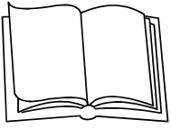

Figure 1–1 shows some details of a type of cargo vessel that is not the most modern, but is still widely used. Your Student Reader contains some plans of more modern vessels. Note the locations of the identified features of these vessels.
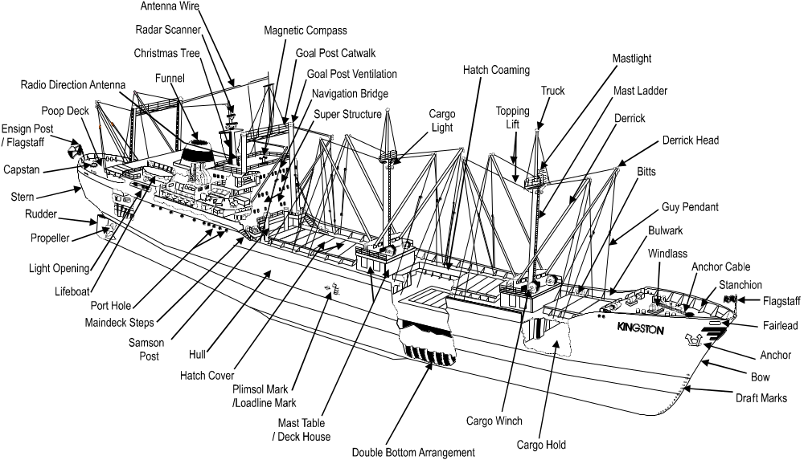
Figure 1–1: Ship features and their locations

Definitions (A–G)
abaft Nearer the stern of the vessel than something else.
accommodation ladder
A folding stairway permanently attached to the ship’s side. When extended, it allows people to embark and disembark.
aft The location at or towards the stern of the vessel.
amidships Midway between bow and stern.
anchor Specially-designed heavy iron implement used for keeping a vessel in a particular position in shallow water.
anchor cable A strong heavy chain, also called an anchor chain, used to attach the anchor to the ship.
antenna wire Antenna used for radio equipment.
astern Towards or beyond the stern. Backwards.
athwartship Across (side-to-side), at right angles to the fore and aft centreline of the ship.
atop Above something else.
beam A measurement of the ship’s width or the longitudinal or transverse girders supporting the ship’s decks.
berth A place for a ship to moor or anchor. Also a bunk on board ship.
bilge The bottom of the hull from the keel around to where the bottom joins the vertical sides of the ship. Also the lower internal part of the hull. Sometimes used loosely to refer to the bilge or drain wells, which are small tanks, where waste, and invariably dirty water collects.
bitt Strong post on a ship for making fast (securing) mooring lines.
block Encased pulley (sheave) or set of pulleys.
bollard Short single posts usually found on wharves, piers, quays, and docks to secure mooring lines.
bow (or stem) The forward part of the vessel.
bow thruster An auxiliary propeller installed transverse under the bow to assist manoeuvring and steering the vessel in confined spaces. Several types of large vessels also have transverse stern thrusters
breadth extreme The greatest breadth (beam) of the vessel measured to the outside of the vessel’s shell plating.
bridge The operations centre of the vessel, usually located on the forward side of the top deck of the superstructure.
bridge wing The open part of the bridge to port and starboard of the wheelhouse extending over the full breadth of the vessel.
brow See gangway.
bulbous bow A bulb-shaped underwater extension of the bow. This improves the hull shape and reduces drag.
bulkhead A vertical partition or wall, separating compartments. They may be transverse or longitudinal.
bulwark Plating built around the outboard edge of the ship’s deck to save people from falling over the side.
capstan A barrel with a vertical axis used for hauling mooring lines.
cargo block Any (pulley) block used for handling cargo including topping lift and derrick-head blocks.
cargo hold See hold.
cargo light Light (or cluster of lights) used when working cargo at night, or below deck at any time.
cargo winch See winch.
catwalk A narrow footbridge running, for example, above the deck from the superstructure to the poop and the forecastle. Usually on deeply-laden vessels with small freeboard such as tankers.
centreline Line running between stern and bow equidistant from the port and starboard side of the vessel.
chain locker A compartment that holds the anchor chains. It is located in the bow atop the forepeak.
christmas tree Usually the main mast, used to carry radar and other antennas and from which signal lights and flags are displayed.
coaming The raised border around the hatch opening to prevent water from running into the hold. It also replaces some of the strength lost when the deck plating was cut for the hatch opening.
cofferdam The empty space between two compartments which carry dissimilar liquids. It is to prevent cross contamination.
deadweight The weight of cargo, fuel, freshwater, stores, and ballast that a fully-loaded vessel carries. It is the difference between the loaded displacement and the light displacement of a vessel.
The term deadweight is also sometimes used rather loosely (and inaccurately) to indicate either the weight of whatever cargo is aboard at any particular moment, or the weight of the cargo plus the weight of the fuel, etc. that is aboard at any particular moment.
deckhouse A light structure on the upper deck and not extending to the ship’s sides. Deckhouses often house ventilation and cargo-handling equipment.
deckline The line marked on the side of the ship from which freeboards are measured. Corresponds to the level of the uppermost continuous (freeboard) deck.
deeptank A compartment that is located in the lower hold of some general dry-cargo vessels to carry small liquid bulk shipments.
depth extreme The depth of the ship measured from the underside of the keel to the top of the deckbeam at the side of the uppermost continuous deck amidships.
derrick Boom pivoted at the bottom of a mast, kingpost, or goalpost and used for loading and discharging cargo. Nowadays, replaced with electric or hydraulic deck cranes.

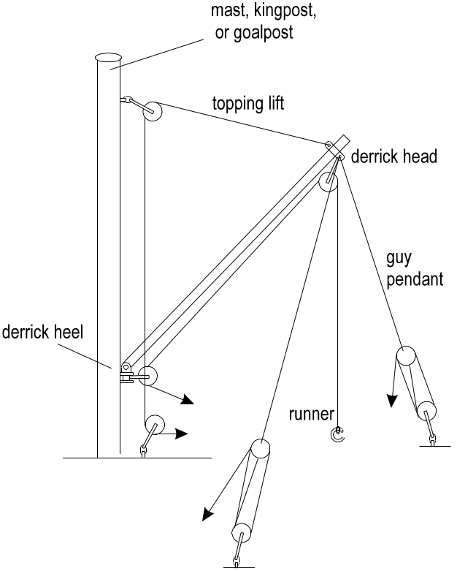
The parts of a derrick
derrick head The top end of a derrick where the topping lift and guy pendants are secured.
derrick heel The bottom end of a derrick where it is pivoted.
displacement Usually refers to the loaded displacement and is the total weight of the ship and everything in it. It varies with the draft and is often represented by the symbol Δ (delta).
double bottom A watertight space between the bottom of the vessel and the bottom of the hold (tanktop) or engine room space. It usually extends from side-to-side and from the collision bulkhead to the after peak bulkhead.
draft The distance from the bottom of the keel to the waterline. How deep the vessel is immersed in the water.
draft marks Numerical marks on the bow and stern, and sometimes amidships, indicating the draft at these locations.
dunnage Loose wood or other material placed between and around cargo to provide ventilation air courses, to keep cargo from touching the sides or floor, and also to wedge the cargo firmly so that it does not move with the motion of the ship at sea.
entrance Part of the hull forward of the parallel body.
engine room The compartment of the vessel where the main propulsion engines are located as well as most of the auxiliary equipment.
ensign Usually the national flag of the country in which the ship is registered. A few countries, like the UK, have a special flag or ensign for their merchant navy.
ensign post The aft flagstaff used to fly the ensign.
fairlead An opening in the ship’s railing through which the mooring lines pass. Also any device, such as a drum, used to lead a rope in the most convenient direction for working.
flagstaff A small post for flags, usually at the bow. The aft flagstaff is the ensign post.
flare The overhang of the bow plating above the waterline. It increases the reserve buoyancy forward, reduces the amount of sea water coming on board, and provides a clear run for the anchor.
fore The location at or towards the bow of the vessel.
forecastle (Pronounced fo’ksel) A short superstructure at the forward end of the vessel.
forepeak Space between the bow (stem) and collision bulkhead.
freeboard The distance from the waterline amidships to the top of the uppermost continuous deck which is marked by the deckline.
freeboard deck The deck from which statutory minimum freeboards are measured. Marked by the deckline.
freeboard, statutory summer
The minimum freeboard a ship most have, by law, for operation in summer conditions as defined by the summer (S) loadline mark and the centre of the Plimsoll mark.
funnel Functions like a chimney to disperse the exhaust fumes from the engines. It is situated on the highest part of the superstructure.
gangway (brow) A movable stairway to allow persons to board the vessel.
goalpost A pair of vertical posts (Samson posts or kingposts) placed on either side of the ship’s centreline. Used to support derricks.
goalpost catwalk A catwalk between goalposts. Used for servicing cargo blocks, etc.
goalpost ventilation
In older ships, ventilation to the cargo holds through the goalposts. Nowadays replaced by electric fans.
guy Rope, wire, or chain used to hold steady or support a boom, derrick, mast, etc. in a fixed position.
guy pendant Rope used to swing a derrick from side to side. See derrick illustration.
Activities
1. Fill in the names of the ship features indicated in Figure 1–2. Check your work by referring to Figure 1–1 in Lesson 1.
2. Label as many of the other features as you can.
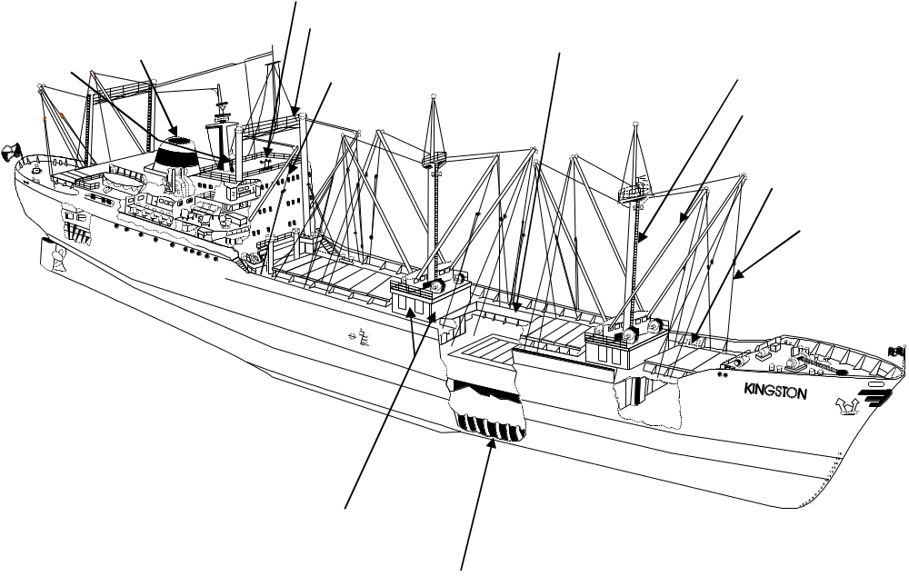
Figure 1–2: Lesson 2 Activity diagram
Practice Exercise for Lesson 2
Test your understanding of Lesson 2 by answering the following questions. Check your answers and read over any parts you found difficult. The answer key is at the back of this unit.
1. What is the space between the stem and the collision bulkhead called?
a. forecastle
b. forepeak
c. freeboard
d. cofferdam
2. Where is the operations centre of a vessel?
a. engine room
b. brow
c. forecastle
d. bridge
3. What prevents contamination between tanks of liquid in the hold?
a. coaming
b. cofferdam
c. deeptank
d. double bottom
4. Where do passengers enter the vessel from the dock?
a. brow
b. catwalk
c. entrance
d. freeboard
5. What is the difference between the loaded and light displacement of a vessel called?
a. depth extreme
b. full displacement
c. deadweight
d. breadth extreme
Lesson 3: Ship terminology (continued)
The illustrations used in the previous two lessons were of a somewhat old-fashioned ship. This type is still in use, but modern cargo vessels have a different design and some different equipment.

Your Student Reader contains a selection of modern cargo vessel plans published in recent editions of the shipping magazine The Motor Ship. There is also a drawing of a hull profile and plan with important parts labelled. Study them.

This lesson continues with the alphabetical listing of shipping terms.

Definitions (H-Z)
halyard Rope used to raise or lower sails or flags.
hatch An opening in the deck providing access to the compartment below.
hatch coaming See coaming.
hatch cover Watertight covers fitted on top of the hatch coamings to seal the hatch.
helm The ship’s steering wheel.
hogging The bending of a vessel caused by the vessel being supported on a wave amidships, but not at its ends. It may also be caused by an excess of cargo loaded at the ends of the vessel.
hold A compartment underdecks that contains the cargo. Most vessels are divided into a number of holds
hull The body of the ship.
keel The main longitudinal structural member that forms the base of the ship.
kingpost Strong, tubular, vertical post used instead of a mast.
length overall (LOA)
The distance from the extreme fore to the extreme aft part of the vessel. It is important for manoeuvring and berth allocation.
lifeboat/life raft Small boats/rafts carried on board ship to allow crew and/or passengers to leave the vessel in case of emergency.
light displacement (lightweight)
The weight of the empty ship without cargo, fuel, freshwater, stores, or ballast.
light opening Windowless opening in structures above the freeboard deck.
loaded displacement
The weight of the ship when laden to the summer loadline. Equal to the light displacement plus the deadweight.
loadline marks Marks on the side of the ship indicating the minimum amount of freeboard a ship must have.
lug A short angle connecting a frame to the deck.
magnetic compass A navigational instrument indicating the direction of the magnetic north pole.
maindeck steps Steps from the superstructure down to the main or freeboard deck.
mast An upright post used for supporting derricks, sails, radio and radar antennas, flags, lookouts (crows nest), lights, etc.
mast ladder A permanently attached ladder for climbing the mast.
mast table A small superstructure build around the base of a mast to support winches.
masthouse A small deckhouse at the foot of the mast.
mastlight Light required for navigation at night or in reduced visibility. Unbroken white light forward with a 225° arc.
midship section A transverse plane equidistant from the fore and aft perpendiculars.
monkey island The top of the wheelhouse, which may serve as an open bridge.
mooring line A heavy rope or wire that secures the vessel to the pier or quay.
mooring winch See winch.
navigation bridge See bridge.
parallel body The portion of the hull in which the cross sectional area remains constant.
pendant Any single rope or wire cable secured at one end to, for example, a mast or derrick, having at the other end a block or thimble.
pilot ladder A portable rope ladder slung over the side of the vessel to allow the pilot to board or disembark from a boat alongside.
plating The sides of the vessel.
Plimsoll mark The marking (a disc) on the side of the ship amidships indicating the legally-limited draft to which the vessel may loaded.
poop A short superstructure at the aft end of the vessel.
poop deck A small deck at the aft end of the vessel.
port The left side of the vessel when facing the bow. Marked at night with a red light. Also a location where a vessel may berth and load and discharge cargo.
porthole Weatherproof circular window in the vessel’s side.
pounding The slamming of the fore end of the vessel as it rises and falls in a heavy sea.
propeller Revolving shaft with blades to propel the vessel through the water.
pumproom The compartment on tankers where the pumps are located to discharge liquid bulk cargo.
radar scanner A rotating radar antenna. Radar is used for navigation and also monitoring weather conditions.
radio direction-finder antenna
A special radio antenna (often two loops) used by the radio-direction finder, a navigational instrument that determines the direction from which radio transmissions are coming.
rudder Steering device suspended under the stern of the ship behind the propeller.
run The portion of the ship aft of the parallel body.
runner The running wire from the winch drum via the top of the derrick or crane to lift cargo. See derrick illustration.
sagging The bending of the ship amidships caused by excessive weight loaded amidships. It is also caused by the bow and stern being supported on wave crests whilst lacking support amidships.
Samson post A strong post used to support a derrick. Also called a kingpost, and in pairs connected by a catwalk, goalposts. Also spelt “Sampson”.
sheer The curvature of the deck rising from midships to the ends of the vessel. The purpose of sheer is to increase reserve buoyancy and reduce the amount of sea water coming on board.
shell The exterior hull structure.
shelterdeck An uppermost deck that cargo ships sometimes have above the maindeck or the freeboard deck. If the shelterdeck can be sealed permanently against the ingress of water, the vessel is called a closed shelterdeck ship, and the space enclosed is included in the gross registered tonnage. Otherwise, the vessel is known as an open shelterdeck vessel, and the space enclosed is not included in the gross registered tonnage.
spar ceiling (sweat boards)
Longitudinal boards inside the hold attached to the frames of the ship. They protect package cargo from touching the sides of the vessel.
springline The mooring line running aft from the bow, or forward from the stern, to keep the ship from moving back and forth while moored alongside.
stanchion Any upright strengthening member or support, such as along the bulwark for the deck.
starboard The right side of the vessel when facing the bow. Marked at night with a green light.
stay Wires or cables that support a mast.
stem The forward part of the vessel.
stern The afterpart of the vessel.
superstructure The structure above the freeboard deck extending across the vessel from side-to-side and forming part of the main hull.
safe working load (SWL)
The maximum weight that may safely be lifted or carried by a piece of equipment. This is usually marked on derricks, cranes, and other cargo handling and transport equipment.
sweat boards See spar ceiling.
tanktop The bottom of the hold.
thimble An oval metal fitting in the eye of a rope or wire.
topping lift A cable used to raise and lower a derrick. See derrick illustration.
truck A cap on the head of a mast or flagstaff, usually with small holes for halyards, etc.
twenty equivalent unit (TEU)
A measure of the capacity of a container vessel. A twenty equivalent unit is the ability to carry one twenty-foot-long container. For example, a 1660 TEU vessel can carry 1660 twenty-foot containers or 830 forty-foot containers.
tweendeck Any deck inside the hold between the tanktop and the weatherdeck.
tweendecker A ship with two or more decks.
ullage Empty space above the liquid in a tank.
weatherdeck The topmost deck covering the holds and exposed to the elements.
wheelhouse The enclosed part of the navigation bridge containing the controls to operate the vessel.
winch A machine having a barrel or drum with a horizontal axis for hauling rope or hoisting objects. A mooring winch is used to haul mooring lines; a cargo winch is used to work cargo.
windlass A special kind of winch used on the forecastle deck for lowering and raising the anchor.
wing See bridge wing.

Activities

Figure 1-3: Lesson 3 Activity diagram
Practice Exercise for Lesson 3
Test your understanding of Lesson 3 by answering the following questions. Check your answers and read over any parts you found difficult. The answer key is at the back of this unit.
1. Where are the controls to navigate a vessel?
a. wheelhouse
b. forecastle
c. monkey island
d. masthouse
2. What is the name of the line that prevents the vessel from moving back and forth when moored alongside?
a. wing
b. stay
c. mooring line
d. springline
3. Which is usually the topmost deck covering the holds?
a. shelterdeck
b. tweendeck
c. weatherdeck
d. freeboard deck
4. What is the weight of the empty ship without cargo, fuel, freshwater, stores, or ballast called?
a. LOA
b. SWL
c. light displacement
d. hogging
5. What is the curvature of the deck from midships to the ends of the vessel called?
a. poop
b. sheer
c. run
d. shell

