COURSE: BUSINESS ACCOUNTING 1
ASSIGNMENT ONE
ISSUE DATE: Friday September 19, 2014
DUE DATE: Monday September 29, 2014
Senior Lecturer: Kirkland Anderson

Question One
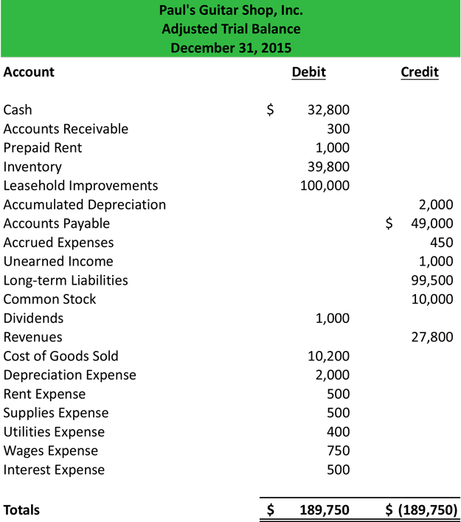
Use the information in the above trial balance and establish:
- Income Statement
- Balance Sheet
Question Two
Prepare T- Account for each of the following transactions and explain how the accounting equation will be affected:
- Ken Gary a business operator purchased building for US$30,000
- Ken purchased goods for sale on credit from P. Henry for $19,000
- Sold goods on credit to H. Murray for $24,500
- Ken Gary received cash of $24,500 from H. Murray
- Ken Make payment of $19,000 to P. Henry
N/B START WITH THE ACCOUNTING EQUATION

