General APA Guidelines Page Format

Your essay should be typed, double-spaced on standard-sized paper (8.5" x 11") with 1" margins on all sides. You should use a clear font that is highly readable. APA recommends using 12 pt. Times New Roman font.
Include a page header (also known as the "running head") at the top of every page. To create a page header/running head, insert page numbers flush right. Then type "TITLE OF YOUR PAPER" in the header flush left using all capital letters. The running head is a shortened version of your paper's title and cannot exceed 50 characters including spacing and punctuation.

Major Paper Sections
Your essay should include three major sections: the Title Page, Main Body, and References.

Title Page
The title page should contain the title of the paper, the author's name, and the institutional affiliation. Include the page header (described above) flush left with the page number flush right at the top of the page. Please note that on the title page, your page header/running head should look like this:
Running head: TITLE OF YOUR PAPER
Pages after the title page should have a running head that looks like this:
TITLE OF YOUR PAPER
After consulting with publication specialists at the APA, OWL staff learned that the APA 6th edition, first printing sample papers have incorrect examples of Running heads on pages after the title page. This link will take you to the APA site where you can find a complete list of all the errors in the APA's 6th edition style guide.
Type your title in upper and lowercase letters centered in the upper half of the page. APA recommends that your title be no more than 12 words in length and that it should not contain abbreviations or words that serve no purpose. Your title may take up one or two lines. All text on the title page, and throughout your paper, should be double-spaced.
Beneath the title, type the author's name: first name, middle initial(s), and last name. Do not use titles (Dr.) or degrees (PhD).
Beneath the author's name, type the institutional affiliation, which should indicate the location where the author(s) conducted the research.
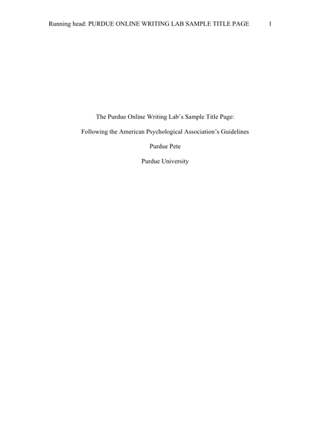
APA Title Page

